Data Structure Lab

(ETCCDS202)

Lab File Submitted to

K.R. Mangalam University

for

Bachelor of Technology

in

Computer Science & Engineering

Spl. Artificial Intelligence & Machine Learning

Submitted by:
Aryan Solanki
Roll No: 2501730347
Faculty:
Mrs. Neetu Chauhan

Unit 1: Foundations & Algorithmic Analysis
PC-01: Stack ADT (Design + Use)
stack = []
MAX = 5

def push(item):
if len(stack) < MAX:
stack.append(item)
print(f"Pushed {item}")
else:
print("Stack Overflow")

def pop():
if not stack:
print("Stack Underflow")
else:
print(f"Popped {stack.pop()}")

def peek():
if stack:
print(f"Top: {stack[-1]}")
else:
print("Stack is empty")

while True:
print("\n1. Push 2. Pop 3. Peek 4. Exit")
ch = input("Enter choice: ")
if ch == '1': push(int(input("Item: ")))
elif ch == '2': pop()
elif ch == '3': peek()
elif ch == '4': break

Output:
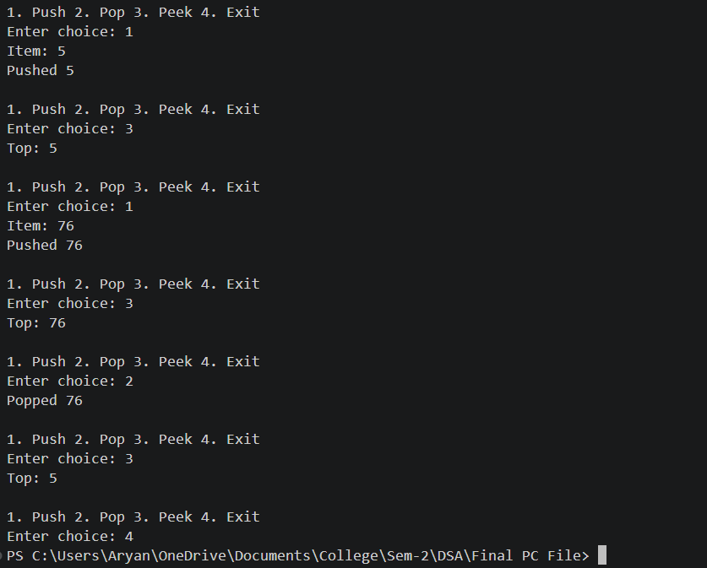

PC-02: Complexity Drill (Operation Counting)
Create 4 snippets: single loop, nested loop, triangular loop, and halving loop. Count operations roughly and map to Big-O. Add best/avg/worst reasoning for linear search and binary search.
def counted_search(arr, target):
ops = 0
for i in range(len(arr)):
ops += 1
if arr[i] == target:
print(f"Found at {i}. Total operations: {ops}")
return
print(f"Not found. Total operations: {ops}")

arr = [10, 20, 30, 40, 50]
print("Best Case (10):")
counted_search(arr, 10)
print("Worst Case (50):")
counted_search(arr, 50)

Output:
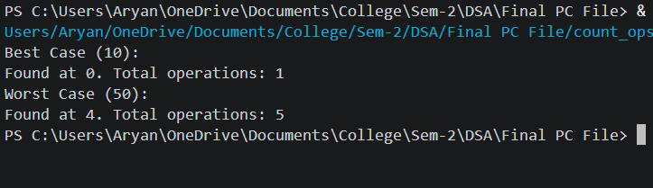

PC-03: Recursive Factorial + Call Stack Trace
Implement factorial(n) recursively for n≥0 and reject invalid input. Draw call stack for factorial(4) showing return values.
def factorial(n, depth=0):
indent = " " * depth
print(f"{indent}Calling factorial({n})")
if n == 0 or n == 1:
print(f"{indent}Returning 1")
return 1
res = n * factorial(n - 1, depth + 1)
print(f"{indent}Returning {res}")
return res

n = int(input("Enter number: "))
print(f"Result: {factorial(n)}")

Output:
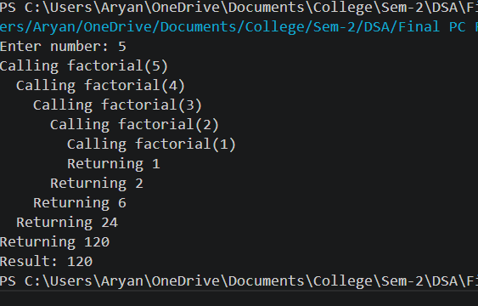

PC-04: Fibonacci (Naive + Memoized) + Call Counter
Implement fib naive(n) and fib memo(n) with call counters. Compare call counts for n=10,20,30 to show performance difference clearly.
naive_calls = 0
memo_calls = 0
memo = {}

def fib_naive(n):
global naive_calls
naive_calls += 1
if n <= 1: return n
return fib_naive(n-1) + fib_naive(n-2)

def fib_memo(n):
global memo_calls
memo_calls += 1
if n in memo: return memo[n]
if n <= 1: return n
memo[n] = fib_memo(n-1) + fib_memo(n-2)
return memo[n]

n = 10
print(f"Naive result: {fib_naive(n)}, Calls: {naive_calls}")
print(f"Memo result: {fib_memo(n)}, Calls: {memo_calls}")

Output:
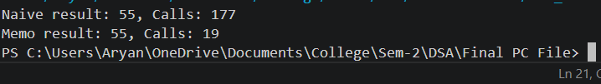

PC-05: Tower of Hanoi
Implement Hanoi(n, src, aux, dst) and print exact move sequence for n=3. Show move count for n=4 and infer complexity.

def hanoi(n, source, target, auxiliary):
if n == 1:
print(f"Move disk 1 from {source} to {target}")
return
hanoi(n-1, source, auxiliary, target)
print(f"Move disk {n} from {source} to {target}")
hanoi(n-1, auxiliary, target, source)

hanoi(3, 'A', 'C', 'B')

Output:
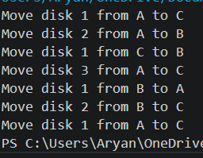

PC-06: Recursive Binary Search + Recurrence Intuition
Implement binary search recursively binarySearch(arr, key, low, high) returning index or -1.
def binary_search(arr, low, high, x):
if high >= low:
mid = (high + low) // 2
print(f"Checking mid-index {mid} (value: {arr[mid]})")
if arr[mid] == x: return mid
elif arr[mid] > x: return binary_search(arr, low, mid - 1, x)
else: return binary_search(arr, mid + 1, high, x)
return -1

arr = [2, 5, 8, 12, 16, 23, 38, 56, 72, 91]
x = 23
print(f"Element {x} at index: {binary_search(arr, 0, len(arr)-1, x)}")
Output:
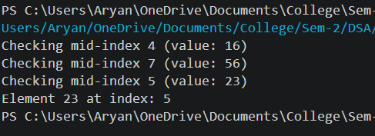

Unit 2: Linear Data Structures
PC-07: Arrays 1D (Operations + Shifting Cost)
Perform insert at start/middle/end and delete at start/middle/end. For each case, compute and report approximate shift count.
arr = [10, 20, 30, 40, 50]
def insert_with_cost(val, pos):
print(f"Inserting {val} at {pos}")
shift_count = len(arr) - pos
arr.insert(pos, val)
print(f"Result: {arr}, Shifting operations: {shift_count}")

insert_with_cost(25, 2)
Output:
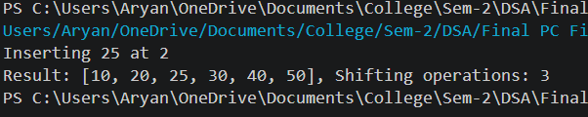

PC-08: Arrays 2D (Matrix Traversal + Ops)
Create a matrix and implement: row sum, column sum, search for a value, and transpose (conceptual output).
matrix = [[1, 2, 3], [4, 5, 6], [7, 8, 9]]
total = 0
for i in range(len(matrix)):
for j in range(len(matrix[0])):
print(f"Element at [{i}][{j}]: {matrix[i][j]}")
total += matrix[i][j]
print(f"Matrix Sum: {total}")

Output:
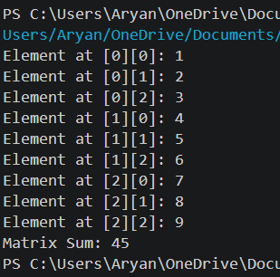

PC-09: Dynamic Array Simulation (Resize + Pop)
Implement capacity/size based DynamicArray with append (doubling resize) and pop from end. Print (size, capacity) after each append.
import sys
dyn_arr = []
for i in range(10):
dyn_arr.append(i)
print(f"Size: {len(dyn_arr)}, Memory size: {sys.getsizeof(dyn_arr)} bytes")

Output:
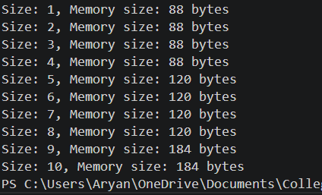

PC-10: Singly Linked List (Core Ops)
Implement dynamic insertion and deletion without shifting. Implement SLL with insert at beginning, insert at end, delete by value, traverse. Handle missing values safely.
class Node:
def __init__(self, data):
self.data = data
self.next = None

class SLL:
def __init__(self): self.head = None

def insert(self, data):
new_node = Node(data)
new_node.next = self.head
self.head = new_node

def display(self):
temp = self.head
while temp:
print(temp.data, end=" -> ")
temp = temp.next
print("None")

s = SLL()
s.insert(10); s.insert(20); s.display()

Output:
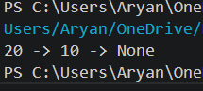

PC-11: Doubly Linked List (Extended Ops)
Implement DLL with insert after node(target,x) and delete at position(pos). Maintain prev/next correctly.
class DNode:
def __init__(self, data):
self.data = data
self.next = self.prev = None

class DLL:
def __init__(self): self.head = None
def insert(self, data):
nn = DNode(data)
if self.head:
self.head.prev = nn
nn.next = self.head
self.head = nn
def traverse_back(self):
t = self.head
while t.next: t = t.next
while t:
print(t.data, end=" <-> ")
t = t.prev
print("None")

d = DLL()
d.insert(1); d.insert(2); d.traverse_back()

Output:
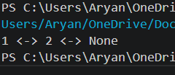

PC-12: Stack using SLL + Parentheses Checker
Implement Stack (push/pop/peek) using SLL head as top. Use it to validate (), , [] in strings.
class Node:
def __init__(self, data):
self.data = data
self.next = None
class Stack:
def __init__(self):
self.top = None # head is top
def push(self, data):
new_node = Node(data)
new_node.next = self.top
self.top = new_node
def pop(self):
if self.top is None:
return None
popped = self.top.data
self.top = self.top.next
return popped
def peek(self):
if self.top is None:
return None
return self.top.data
def is_empty(self):
return self.top is None
def check_balanced(expr):
stack = Stack()
pairs = {')': '(', '}': '{', ']': '['}
for char in expr:
if char in '({[':
stack.push(char)
elif char in ')}]':
if stack.is_empty():
return False
if stack.pop() != pairs[char]:
return False
return stack.is_empty()
tests = ["((1+2)*3)","{[()]}","{[(])}","(((","[]{}()","(]"]
for t in tests:
print(f"{t} -> {check_balanced(t)}")
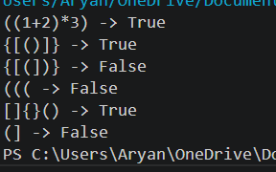
Output:

PC-13: Queue using SLL (O(1) operations)
Implement queue with head+tail pointers and connect to BFS usage.
class Node:
def __init__(self, data):
self.data = data
self.next = self.prev = None

class Queue:
def __init__(self): self.front = self.rear = None
def enqueue(self, data):
nn = Node(data)
if not self.rear: self.front = self.rear = nn
else:
self.rear.next = nn
self.rear = nn
def dequeue(self):
if not self.front: return "Empty"
val = self.front.data
self.front = self.front.next
if not self.front: self.rear = None
return val

q = Queue()
q.enqueue(100);q.enqueue(200); print(q.dequeue())

Output:
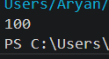

Unit 3: Sorting Algorithms
PC-14: O($n^{2}$) Sorts + Counting
Bubble Sort with swap counts.
def bubble_sort(arr):
swaps = 0
n = len(arr)
for i in range(n):
for j in range(0, n-i-1):
if arr[j] > arr[j+1]:
arr[j], arr[j+1] = arr[j+1], arr[j]
swaps += 1
print(f"Swaps: {swaps}")
bubble_sort([64, 34, 25, 12])

Output:
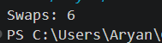

PC-15: Insertion Sort (Advantage on Nearly Sorted)
Implement insertion sort and optionally print pass-wise array for a small input.
def insertion_sort(arr):
comps = 0
for i in range(1, len(arr)):
key = arr[i]
j = i - 1
while j >= 0:
comps += 1
if key < arr[j]:
arr[j+1] = arr[j]
j -= 1
else: break
arr[j+1] = key
return comps

print(f"Comps (Sorted): {insertion_sort([1,2,3,4,5])}")
print(f"Comps (Reverse): {insertion_sort([5,4,3,2,1])}")

Output:
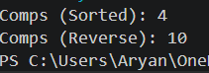
PC-16: Merge Sort (Stable, O(n log n))
Implement merge(left,right) conceptually and merge sort. Note time O(n log n) and space O(n).
def merge_sort(arr):
if len(arr) > 1:
mid = len(arr)//2
L, R = arr[:mid], arr[mid:]
merge_sort(L); merge_sort(R)
i = j = k = 0
while i < len(L) and j < len(R):
if L[i] <= R[j]: arr[k] = L[i]; i += 1
else: arr[k] = R[j]; j += 1
k += 1
while i < len(L): arr[k] = L[i]; i += 1; k += 1
while j < len(R): arr[k] = R[j]; j += 1; k += 1

arr = [38, 27, 43, 3, 9, 82, 10]
merge_sort(arr); print(arr)

Output:
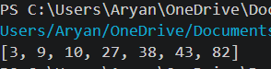

PC-17: Quick Sort (Partition + Worst Case)
Implement quick sort using a clear partition scheme (e.g., last pivot). Explain worst-case scenario (already sorted + bad pivot).
def partition(arr, low, high):
pivot = arr[high]
i = low - 1
for j in range(low, high):
if arr[j] <= pivot:
i += 1
arr[i], arr[j] = arr[j], arr[i]
arr[i+1], arr[high] = arr[high], arr[i+1]
return i + 1

def quick_sort(arr, low, high):
if low < high:
pi = partition(arr, low, high)
quick_sort(arr, low, pi - 1)
quick_sort(arr, pi + 1, high)

arr = [10, 7, 8, 9, 1, 5]
quick_sort(arr, 0, len(arr)-1); print(arr)

Output:
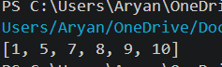

PC-18: Heap Sort (Heapify + Sorting)
Implement heapify + heap sort (min or max). Explain why heap sort is not stable.
def heapify(arr, n, i):
largest = i
l, r = 2 * i + 1, 2 * i + 2
if l < n and arr[i] < arr[l]: largest = l
if r < n and arr[largest] < arr[r]: largest = r
if largest != i:
arr[i], arr[largest] = arr[largest], arr[i]
heapify(arr, n, largest)

def heap_sort(arr):
n = len(arr)
for i in range(n // 2 - 1, -1, -1): heapify(arr, n, i)
for i in range(n-1, 0, -1):
arr[i], arr[0] = arr[0], arr[i]
heapify(arr, i, 0)

arr = [12, 11, 13, 5, 6, 7]
heap_sort(arr); print(arr)

Output:
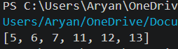

PC-19: Benchmark Harness (Datasets + Timing Table)
Generate random/sorted/reverse datasets for sizes 1000/5000/10000. Time insertion, merge, quick and print a table (27 values).
import random, time
def insertion(a):
a = a.copy()
for i in range(1, len(a)):
key, j = a[i], i-1
while j >= 0 and a[j] > key:
a[j+1] = a[j]
j -= 1
a[j+1] = key
return a

def merge(a):
if len(a) <= 1: return a
m = len(a)//2
l, r = merge(a[:m]), merge(a[m:])
res, i, j = [], 0, 0
while i < len(l) and j < len(r):
if l[i] < r[j]: res.append(l[i]); i += 1
else: res.append(r[j]); j += 1
return res + l[i:] + r[j:]

def quick(a):
if len(a) <= 1: return a
p = a[len(a)//2]
left = [x for x in a if x < p]
mid = [x for x in a if x == p]
right= [x for x in a if x > p]
return quick(left) + mid + quick(right)

def gen(n, case, seed):
random.seed(seed)
if case == "random": return [random.randint(1, 100000) for _ in range(n)]
if case == "sorted": return list(range(n))
return list(range(n, 0, -1)) # reverse
def run():
sizes = [1000, 5000, 10000]
cases = ["random", "sorted", "reverse"]
algos = {"Insertion": insertion, "Merge": merge, "Quick": quick}

print(f"{'Size':<6}{'Case':<10}{'Algo':<10}{'Time(s)':<10}")
print("-"*36)

for n in sizes:
for c in cases:
data = gen(n, c, 42)
for name, f in algos.items():
t1 = time.perf_counter()
f(data)
t2 = time.perf_counter()
print(f"{n:<6}{c:<10}{name:<10}{(t2-t1):<10.5f}")

run()

Output:
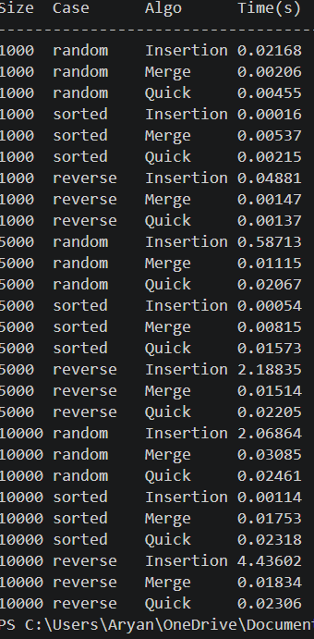

Unit 4: Non-Linear & Advanced Data Structures
PC-20: BST Insert/Search/Inorder
Implement BST insert, search, inorder traversal. Use a fixed dataset and print inorder result.
class BSTNode:
def __init__(self, key):
self.left = self.right = None
self.val = key

def insert(root, key):
if root is None: return BSTNode(key)
if key < root.val: root.left = insert(root.left, key)
else: root.right = insert(root.right, key)
return root

def inorder(root):
if root:
inorder(root.left)
print(root.val, end=" ")
inorder(root.right)

r = insert(None, 50); insert(r, 30); insert(r, 70); inorder(r)

Output:
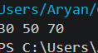

PC-21: BST Delete (All Cases)
Implement delete handling: leaf, one child, two children (successor). Print inorder after each delete as proof.
class Node:
def __init__(self, val):
self.val = val
self.left = None
self.right = None
def insert(root, key):
if root is None:
return Node(key)
if key < root.val:
root.left = insert(root.left, key)
else:
root.right = insert(root.right, key)
return root
def inorder(root):
if root:
inorder(root.left)
print(root.val, end=" ")
inorder(root.right)
def min_value_node(node):
curr = node
while curr.left:
curr = curr.left
return curr
def delete_node(root, key):
if root is None:
return root

if key < root.val:
root.left = delete_node(root.left, key)

elif key > root.val:
root.right = delete_node(root.right, key)

else:
# Case 1: Leaf node
if root.left is None and root.right is None:
return None

# Case 2: One child
elif root.left is None:
return root.right
elif root.right is None:
return root.left

# Case 3: Two children
temp = min_value_node(root.right) # inorder successor
root.val = temp.val
root.right = delete_node(root.right, temp.val)

return root
# Build BST
root = None
values = [50, 30, 70, 20, 40, 60, 80]

for v in values:
root = insert(root, v)

print("Initial Inorder:")
inorder(root)
print("\n")

# Deletions
delete_keys = [20, 30, 50]

for key in delete_keys:
print(f"Deleting {key}...")
root = delete_node(root, key)
print("Inorder after deletion:", end=" ")
inorder(root)
print("\n")

Output:
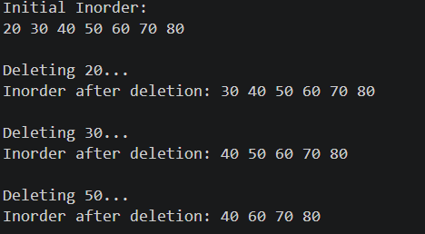

PC-22: Heap / Priority Queue (Industry)
Min-heap or max-heap with insert, peek, extract-min/max. Show extraction order to verify correctness.
import heapq
pq = []
heapq.heappush(pq, (2, "Task B"))
heapq.heappush(pq, (1, "Task A"))
heapq.heappush(pq, (3, "Task C"))
while pq:
print(heapq.heappop(pq))
Output:
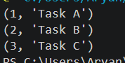
PC-23: Graph Build (Adjacency List)
Create 5–7 nodes and 8–10 edges. Store as adjacency list and print readable structure.
graph = {}
def add_edge(u, v, w):
if u not in graph: graph[u] = []
graph[u].append((v, w))

add_edge('A', 'B', 5); add_edge('B', 'C', 3)
print(graph)

Output”
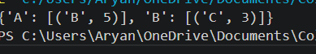

PC-24: BFS Traversal
Implement BFS(start) using queue and visited set. Print BFS order from a chosen start node.
graph = {}
def add_edge(u, v, w):
if u not in graph: graph[u] = []
graph[u].append((v, w))

add_edge('A', 'B', 5); add_edge('B', 'C', 3)

def bfs(graph, start):
visited = [start]
queue = [start]
while queue:
u = queue.pop(0)
print(u, end=" ")
for v in graph.get(u, []):
if v[0] not in visited:
visited.append(v[0])
queue.append(v[0])

bfs(graph, 'A')

Output:
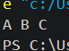

PC-25: DFS Traversal
Implement DFS(start) recursively or using stack. Print DFS order from start node.
graph = {}
def add_edge(u, v, w):
if u not in graph: graph[u] = []
graph[u].append((v, w))

add_edge('A', 'B', 5); add_edge('B', 'C', 3)

visited = set()
def dfs(graph, node):
if node not in visited:
print(node, end=" ")
visited.add(node)
for neighbor in graph.get(node, []):
dfs(graph, neighbor[0])

dfs(graph, 'A')

Output:
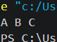

PC-26: Hash Table (Separate Chaining)
Implement insert/get/delete with chaining. Use key % tableSize hash. Demonstrate collisions with multiple keys.
class HashTable:
def __init__(self, size):
self.size = size
self.table = [[] for _ in range(size)]
def hash_fn(self, key): return key % self.size
def insert(self, key, val):
idx = self.hash_fn(key)
self.table[idx].append((key, val))
def get(self, key):
idx = self.hash_fn(key)
for k, v in self.table[idx]:
if k == key: return v
return None

ht = HashTable(5); ht.insert(10, "Ten"); print(ht.get(10))

Output:
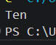

PC-27: Trie (Prefix Tree)
Implement trie insert/search/startsWith. Use a small word set and test prefix searches.
class TrieNode:
def __init__(self):
self.children = {}
self.is_end = False

class Trie:
def __init__(self): self.root = TrieNode()
def insert(self, word):
node = self.root
for char in word:
if char not in node.children: node.children[char] = TrieNode()
node = node.children[char]
node.is_end = True
def search(self, word):
node = self.root
for char in word:
if char not in node.children: return False
node = node.children[char]
return node.is_end

t = Trie(); t.insert("apple"); print(t.search("apple"))

Output:
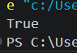

PC-28: Bloom Filter (Concept + Toy Demo)
Explain bloom filter (bit array + k hash functions). Demonstrate toy membership test and false positive concept.
class BloomFilter:
def __init__(self, size):
self.bit_array = [0] * size
def add(self, item):
idx1 = hash(item) % len(self.bit_array)
idx2 = (hash(item) // 7) % len(self.bit_array)
self.bit_array[idx1] = 1
self.bit_array[idx2] = 1
def check(self, item):
idx1 = hash(item) % len(self.bit_array)
idx2 = (hash(item) // 7) % len(self.bit_array)
return self.bit_array[idx1] == 1 and self.bit_array[idx2] == 1

bf = BloomFilter(20); bf.add("test"); print(bf.check("test"))

Output:


